Directions for Responding to NOFA’s and On-Line Submittal

TIMELINE FOR NOFA:

December 7, 2022 NOFA Open
December 8, 2022 Pre-Proposal Conference virtually via Microsoft Teams 12:00pm – 2:00pm
December 12, 2022 Questions due by 5:00pm to Meghan Murphy at mmurphy@atlantaregional.org
December 16, 2022 Questions and answers posted to ARC website by 5:00pm
December 23, 2022 Proposals due by 5:00pm, submitted via ARC website
January 6, 2022 Award Announcement by 5:00pm
* Microsoft Teams link for the Pre-Proposal Conference can be found in the NOFA

Go to ARC website to download the documents at http://atlantaregional.org/procurement/ and
save the documents on your computer

- Please read the NOFA in its entirety

2. Attend the Pre-Proposal Conference to have any questions addressed and/or submit
questions via email to the ARC contact person listed in the NOFA.

4. To view all questions and answers asked at Pre-Proposal Conference and via email, please go to the Atlanta Regional Commission website procurement page where they will be listed at http://atlantaregional.org/procurement/

5. The following documents must be completed fully and returned for a submittal to be
considered complete:

- Applicant Transmittal Cover Page – Includes contact information, charts, checklist of items required, and signature requirement. Fill it out completely and have it signed by the individual in your organization who is authorized to execute contracts.

- Proposal Response Template –Only respond to the service specific questions for which you are proposing to provide. All questions must be answered in the template. All answers to questions are to be brief and to the point.

c. Financial Components Workbook which is inclusive of:
Budget Narrative
Budget Summary

6. Ensure that you have all the checklist attachments required.

NOFA Submission Instructions
- Once you are ready to submit your NOFA proposal, make sure all the documents you are submitting (all of the required templates as well as required attachments mentioned in the NOFA) are in a single folder.
- To Zip that folder:
  - Right click on the folder with all of your documents
  - Select your zipping tool (i.e. 7-Zip) and select add to archive
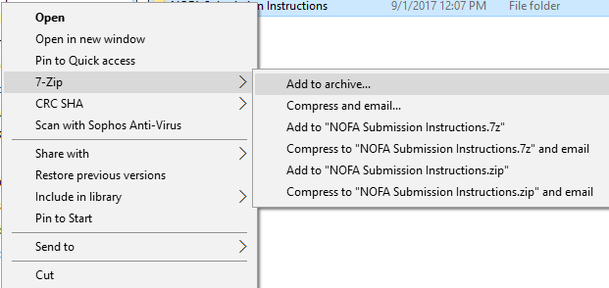
  - In the window that pops up, press OK at bottom
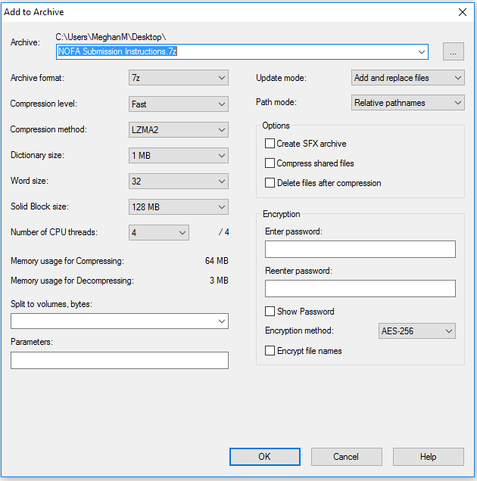

  - The file should now be saved as a compressed file.

- To submit your proposal, go to the ARC website’s procurement page at: https://atlantaregional.org/procurement/
- The online form will be on this page. Click on the Submission Form underneath the posting for the NOFA.
- Fill out the information on the form and attach your zipped files.
- Click Submit.
- You will receive an email confirming receipt of your submission.

