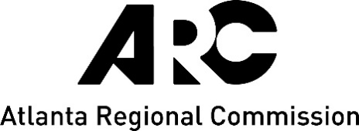
FOR IMMEDIATE RELEASE

Contact:

Paul Donsky

pdonsky@atlantaregional.org

404-202-4662
ARC Survey Seeks Input from Cherokee County Residents to Guide Update of Region’s Long-Range Transportation Plan
(ATLANTA – June xx, 2023) The Atlanta Regional Commission (ARC) has launched an online survey to gather input from Cherokee County residents and others across metro Atlanta to shape a major update to the Metropolitan Transportation Plan (MTP), the region’s long-term blueprint that guides transportation investments and envisions a better future.
The survey asks respondents their views on a wide range of topics that are key to long-range planning, including transportation, housing, technology, and the environment. Questions include:
- How should we prioritize transportation investments?
- What are the biggest issues facing metro Atlanta today?
- What are the best long-term solutions to our traffic challenges?
- How can local governments provide more affordable housing?
“This plan update comes during a period of strong regional growth and breathtaking change, as technology advances, our climate changes, and federal priorities shift. It’s imperative that we develop a forward-thinking plan that meets the needs of our diverse communities,” said Anna Roach, Executive Director & CEO at ARC.
ARC administers the MTP in its role as the region’s Metropolitan Planning Organization. The plan programs about $173 billion in federal, state, and local funding through 2050. The funds will help ease traffic congestion, provide new transit and bike-ped options, improve safety, and provide commute alternatives.
The plan aims to meet the following objectives that align with ARC’s new strategic framework:
- Foster the development of healthy, safe, livable communities.
- Strategically invest in infrastructure to provide an equitable, accessible, and safe transportation network and improve the region’s resiliency.
- Build a competitive economy that is inclusive, innovative, and resilient, with a highly educated and skilled workforce able to meet employers’ needs.
The survey is part of an on-going public participation process to support the MTP update that includes partnership with local governments, focus groups and public meetings, and a public comment period. The plan is expected to be adopted in early 2024.
For more information about the Metropolitan Transportation Plan and take the survey, visit atlantaregional.org/mtp-update/.

###
The Atlanta Regional Commission (ARC) is the official planning agency for the 11-county Atlanta Region, including Cherokee, Clayton, Cobb, DeKalb, Douglas, Fayette, Forsyth, Fulton, Gwinnett, Henry and Rockdale counties as well as the City of Atlanta and 74 other cities. The mission of the Atlanta Regional Commission is to foster thriving communities for all in the Atlanta region through collaborative, data-informed planning and investments.

