Atlanta Regional Commission
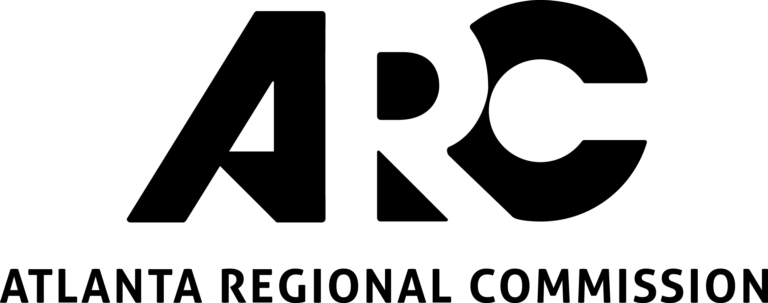
229 Peachtree Street, Suite 100
Atlanta, Georgia 30303

2022 LCI Call for Ideas

DISCLAIMER: We strongly recommend you reference the guidebook while filling out this application.

- Prior to starting your application, did you review the application guidebook, and do you have a clear understanding of the LCI Program?
☐ Yes, I acknowledge that I reviewed the guidebook and fully understand the program as explained.

SECTION I. APPLICANT INFORMATION:

- Name of organization
(eligible applicants include governmental entities, or CIDs

Name of primary contact person:

Title:

Department:

Address/City/State/Zip:

Telephone: E-mail:

SECTION II. TYPE OF ASSISTANCE:

- Please select the type of assistance you are seeking. You may check multiple boxes if your project requires multiple types of assistance.

☐ Catalytic: Promotes the creation of transit-oriented development around and existing or planned ART, BRT, LRT, or HRT station.
☐ Catalytic: Supports the revitalization of the community’s existing or planned downtown district.
☐ Tactical: Advances the implementation of a priority action identified in a study within the LCI area.
Section III. PROJECT INFORMATION:
Please be brief and specific. Responses are limited to 1,400 characters

- Name of project:

- Name of LCI area and last plan adoption date:

- Total cost of project:

- Proposed local match (Minimum 20% of project cost):

- Project location/extents:

- Has this project been identified in a previous LCI study, Comprehensive Plan or another recently completed study? (please check one) ☐YES ☐NO

- If YES, please name the study, and reference the section or page that relates to this project:

- Is the project within an existing LCI area? If yes, please include your report of accomplishments of your LCI work program with your application. (please check one) ☐YES ☐NO

- Provide a brief study goal and description. In your project description, please describe the specific products and deliverables that this study will create.

- How does this LCI study address a need in your community?

- How does your LCI study advance or address one or more of the following LCI priorities. If the application is selected, the answers provided will be incorporated within the LCI study scope. Not all projects need to advance all the LCI priorities.
  - Smart Technology
    - What specific issues will be addressed through the use of technology?
    - How will technology improve mobility and safety?
  - Creative Placemaking
    - What types of investments are you looking to make?
    - How will the arts community be involved throughout the process?
  - Housing
    - How would the study address housing challenges identified by the Regional Housing Strategy for this area?
    - What housing solutions will be explored further?
  - Climate Change
    - How will be the study promote the preservation of natural resources?
    - How does the study address the impacts of flooding and extreme weather events?
    - How will the study incorporate green infrastructure into transportation projects?
    - How will the study incorporate community electric vehicle charging?

- ARC strongly recommends LCI applicants to actively engage community-based organizations in the development of their LCI application. List stakeholders (e.g., Community Based Organizations (CBOs), businesses and/or institutions, and local officials) involved in the development of this application, as well as how they will be involved in the planning process, if the application is selected.
- Who in your community has been historically under-represented in local planning processes? How will these individuals or groups be included in this planning process?

Section IV. COMMITMENT:

- All applications should include a letter of commitment from the Chief Elected Official, or a Council/Commission Resolution, indicating commitment to the implementation of the project and the matching funds.

- Non-governmental organizations applying for assistance shall include a letter of commitment to the implementation of the project and for matching funds (if applicable) from its Executive Director or Board Chairperson, as well as a letter of support from the underlying jurisdiction.

- If entities other than the applicant are providing matching funds, please include letters of commitment to the matching fund from those funders.

- Other letters of support are encouraged

