Atlanta Regional Commission
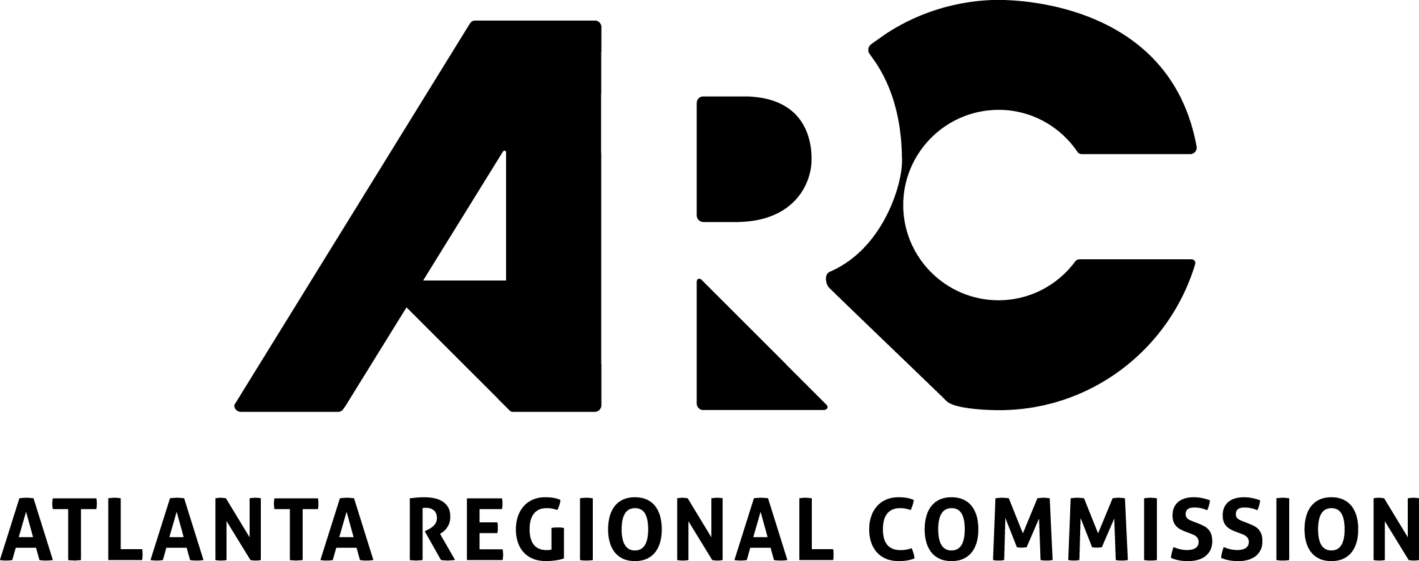
229 Peachtree Street, Suite 100
Atlanta, Georgia 30303

2022 Community Development Assistance Program Application

DISCLAIMER: We strongly recommend you reference the guidebook while filling out this application.

As part of ARC’s ongoing efforts to create outcomes that benefit community members that have been disproportionately and negatively impacted by past planning outcomes, ARC will prioritize assistance in 2022 to applications that demonstrate an active partnership between the local government and Community Based Organizations (CBO).

Prior to starting your application, did you review the application guidebook, and do you have a clear understanding of the Community Development Assistance Program?

☐ Yes, I acknowledge that I reviewed the guidebook and fully understand the program as explained.

SECTION II. APPLICANT INFORMATION:

Name of applicant:
(eligible applicants include governmental entities, CIDs, and 501(c)3 non-profit organizations)

Name of primary contact person:

Department/Title:

Jurisdiction:
Telephone:
E-mail:

Name of partnering Community Based Organizations (CBO):

Name of primary contact person:

Title:
Telephone:
E-mail:

SECTION I. TYPE OF ASSISTANCE:

- Select the type of assistance you are seeking. Keep in mind that grant funds are limited, and very few projects may be awarded grant assistance each year. Partner assistance may require scope and application changes upon review.

☐ Technical Assistance (ARC)
☐ Technical Assistance (Partner)*
☐ Grant Assistance
☐ I do not have a preference

*If interested in assistance through ULI Atlanta Technical Assistance Panels (TAPs) or Georgia State University’s Graduate Capstone Projects, please complete their respective applications.

- Indicate the applicable type of project and its associated local contribution or fee (Please refer to the local contribution and fee tables outlined in the CDAP Guidebook on pages 28 and 29).

ARC Assistance
☐ Retreat Facilitation: $500/day
☐ Training for Planning Officials: $500-1,000
☐ Special Study: $2,500-5,000
☐ Strategic Initiative: $3,000
☐ Zoning Audit: $5,000
☐ Land Use & Development Plan (Minor): $5,000
☐ Housing Assessment: $7,500
☐ Land Use & Development Plan (Major): $10,000
☐ Housing Study - $10,000-15,000

Partner Assistance
☐ Georgia Conservancy’s Sustainable Growth Program: $5,000-25,000
☐ Georgia Institute of Technology’s Graduate Studio Project: $10,000-50,000

Grant Assistance
☐ Grant funded study total cost: ________; Local Match (20%) ______________

Section III. PROJECT INFORMATION:
Short Answer Questions are limited to 200 words unless otherwise noted.

- Title of project:

- Project location/extents (a map of study area is encouraged):

- Provide a brief project description.

- Specifically describe the final deliverable you envision for your project (i.e. planning report, technical memo, slide deck, etc.)

- Has this project been identified in a previous LCI Study, Comprehensive Plan or another recently completed study/plan? (check one)
☐YES ☐NO
- If YES, name the study, and reference the section or page that relates to this project:

- Select the priority issue area(s) that your project addresses. Your project does NOT need to address all of the priority issue areas. (Select up to two.)

☐ Access to Healthy Food ☐ Creative Placemaking

☐ Impacts of Climate Change ☐ Historic Preservation

☐ Housing Affordability ☐ Lifelong Communities

☐ Smart Technology ☐ Workforce Development

- Describe how this project addresses a need in your community specifically as it relates to the priority issues area(s) identified in question 9:

- CDAP encourages applicants to engage stakeholders and community groups prior to submitting an application in the formation of a project. List potential stakeholders (e.g., Community Based Organizations (CBOs), businesses and/or institutions, and local officials) identified for this project, and how were they included in the development of the nominated project. How will these individuals or groups continue to be included in this planning process?

- Who in your community has been historically under-represented in local planning processes? How will these individuals or groups be included in this planning process?

- Describe how the proposed project will advance social equity as defined in the CDAP guidebook on page 5.

- Describe how the proposed project will advance community resiliency as defined in the CDAP guidebook on page 5.

Section IV. COMMITMENT:

- All applications should include a letter of commitment from the Chief Elected Official, or a Council/Commission Resolution, indicating commitment to the implementation of the project and local contribution.

- Non-governmental organizations applying for assistance shall include a letter of commitment to the implementation of the project and local contribution (if applicable) from its Executive Director or Board Chairperson, as well as a letter of support from the underlying jurisdiction.

- If entities other than the applicant are providing the local contribution, please include letters of commitment to the local contribution from those funders.

- Other letters of support are encouraged.

