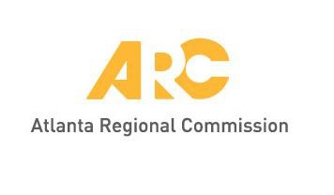
Meeting materials will be posted at
www.atlantaregional.org/tcc before each meeting.

UPDATED AGENDA

Transportation Coordinating Committee

ARC Conference Center | 229 Peachtree Street NE | Atlanta, GA 30303
9:30 a.m., Friday, November 4, 2022

- Welcome, Public Comment Kofi Wakhisi, ARC

- Drive Electric Georgia Program Overview Sumner Pomeroy, Clean Cities Georgia
Clean Cities Georgia will share information about the Drive Electric Georgia program and how communities can consider electrification options for future transportation needs.

- Regional Transportation Plan (RTP) Amendment #6 and Transportation Improvement Program (TIP) Update (FIRST READ AND PUBLIC HEARING) Jean Hee Barrett &
Patrick Bradshaw, ARC
ARC will brief TCC and hold a public hearing on the TIP Amendment/Update. These TIP changes include adjustments to project costs, additional projects and other design changes.

- Regional Safety Strategy (RSS) Plan (FIRST READ) ARC Staff
Staff will brief TCC on the final Regional Safety Strategy document. The Regional Safety Strategy’s goal is to help the region proactively achieve safety goals and build a safe transportation system. 2023 performance targets will also be introduced.

- 2022 Draft Unified Planning Work Program (UPWP) (FIRST READ) Kofi Wakhisi, ARC
Each year ARC prepares a transportation work program for critical items to undertake in the upcoming year. Highlights of the draft work program for the upcoming year will be discussed. Final reviews of the work program are scheduled for TCC, TAQC and ARC Board in December.

- Other Items and Announcements Group

- Adjourn Chair
1 Public comment should be emailed to jorr@atlantaegional.org. The deadline to receive public comment - and have this distributed to TCC members before the meeting - is 4:00 p.m., Thursday, November 3, 2022.

