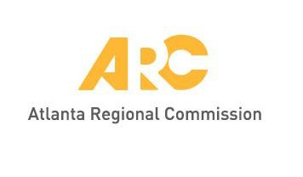
Meeting materials will be posted at
www.atlantaregional.org/tcc before each meeting.

UPDATED AGENDA

Transportation Coordinating Committee – Virtual Meeting
John Orr, Chair
9:30 a.m., Friday, October 7, 2022

Click here to join the meeting
Note: Click on purple text above to access the virtual meeting

Or call in (audio only)

+1 470-419-6063 United States, Atlanta
Phone Conference ID: 126 077 778#

- Welcome, Public Comment John Orr, ARC

- Infrastructure Investment and Jobs Act (IIJA) New Funding
Opportunities and Regional Coordination Activities ARC staff
Staff will highlight new Notices of Funding Opportunity (NOFOs) that are relevant for local communities. Staff will also update TAQC members on discussions underway with TCC members in identifying possible opportunities for regional collaboration on discretionary grant applications.

- Regional Safety Strategy (RSS) Plan Tejas Kotak, ARC
Staff will brief TCC on the final Regional Safety Strategy document in preparation for a future action item. The Regional Safety Strategy’s goal is to help the region proactively achieve safety goals and build a safe transportation system.

- Other Items and Announcements Group

- Adjourn Chair
1 Public comment should be emailed to jorr@atlantaegional.org. The deadline to receive public comment - and have this distributed to TCC members before the meeting - is 4:00 p.m., Thursday, October 6, 2022.

