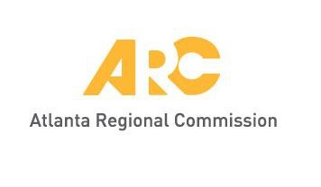
Meeting materials will be posted at
www.atlantaregional.org/tdm before each meeting.
During meeting, wi-fi access available at “AtlRegional-Guest”,
password “Community.”

PROPOSED AGENDA

Transportation Demand Management Coordinating Committee Meeting
Roz Tucker, Chair

September 15, 2020 11:30 AM – 12:30 PM
https://attendee.gotowebinar.com/register/3195054755553738251

After registering, you will receive a confirmation email containing information

about joining the webinar.

- Welcome: Announce purpose of Special Called Meeting Roz Tucker
Public Comment period1

- Regional TDM Plan Update – Intent/Achievements Roz Tucker
- Regional TDM Plan Update – Survey Results and Next Steps Tanisha Hall

- Adjourn Chair

1 A 10-minute period for public comments is designated at the beginning of each regular TDM meeting. Each commenter must sign up before 9:30 AM on the meeting date. Each speaker will be limited to two minutes. If the comment period expires before all citizens have an opportunity to address the Committee, citizens will be invited to provide their comments in writing.

