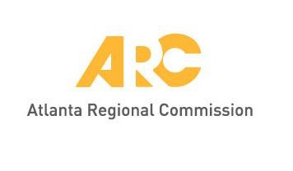
Meeting materials will be posted at
www.atlantaregional.org/tcc before each meeting.

Transportation Coordinating Committee (IN-PERSON MEETING)

ARC Conference Center | 229 Peachtree Street NE | Atlanta, GA 30303
John Orr, Chair
9:30 a.m., Friday, September 9, 2022

- Welcome and Public Comment period1 John Orr, ARC

- Update on TIP Solicitation DRAFT Staff Recommendations Jean Hee Barrett
Patrick Bradshaw, ARC

ARC staff will provide highlights on the DRAFT recommendations for the TIP solicitation.

- Roundtable Discussion on the Infrastructure Investment and Jobs Act (IIJA)
and Inflation Reduction Act (IRA) David Haynes, ARC

ARC will provide an update on the recently passed Inflation Reduction Act (IRA). Roundtable discussion will occur to hear local perspectives on programs that have garnered the most interest. Other items for discussion include gauging the potential in the future for communities to jointly partner on multi-jurisdictional projects.

- Other Items and Announcements Group

- Adjourn Chair

1 A 10-minute period for public comments is designated at the beginning of each regular TCC meeting. Each commenter must sign up before 9:30 AM on the meeting date. Each speaker will be limited to two minutes. If the comment period expires before all citizens have an opportunity to address the Committee, citizens will be invited to provide their comments in writing.

