Atlanta Regional Commission
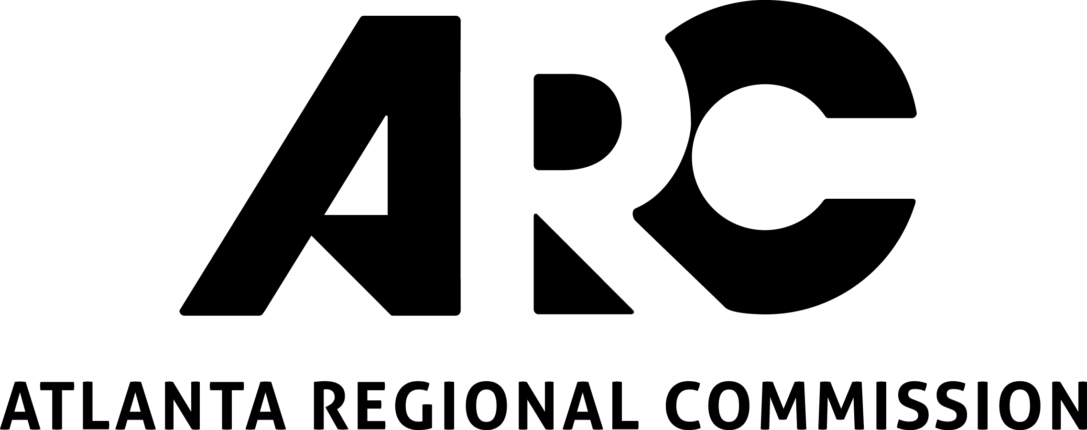
229 Peachtree St, Suite 100
Atlanta GA, 30303

2018 Application for NEW LCI Studies

Applicant Information:

Name of responsible organization:

(Eligible applicants include governmental entities, or Community Improvement Districts)

Click here to enter text.

Name of contact person: Click here to enter text.

Title: Click here to enter text. Department: Click here to enter text.

Address/City/State/Zip: Click here to enter text.

Telephone: Click here to enter text. E-mail: Click here to enter text.

Name of Study: Click here to enter text.

Location/jurisdiction(s) of study: Click here to enter text.

Eligible Study Area Categories:

Applicants are strongly encouraged to discuss the boundaries of a study location with ARC staff prior to
submitting the application for consideration.

Study Area Types:
Eligible study areas are listed below and are identified on the Unified Growth Policy Map
(UGPM) and the Regional Development Guide. Appropriately defined LCI study areas must meet one of the categories below.

- Local Centers:
Includes, as identified on the UGPM and Regional Development Guide: Town Centers, Crossroads Communities, Village Centers, (as well as Major Retail Centers, Wellness and University Districts unless otherwise contained in a Regional Center as described below).

- Regional Centers:
Includes, as identified on the UGPM and the Regional Development Guide: Regional Centers, Station Communities, Community Activity Centers, Recreation/Cultural/Entertainment Districts, and Regional Town Centers.

- Corridors:
Eligible corridors must connect two or more LCI areas or “places” as identified on the UGPM. LCI corridors should be relatively short in length (approximately ½-mile to 4 miles) and must have logical termini. Corridor studies will be focused on creating multi-modal, complete streets, connecting LCI areas or existing centers. Land uses between the LCI areas or existing centers should emphasize efficient multi-modal mobility and safety and efficient utilization of existing infrastructure, and should not divert growth opportunities from adjacent centers/nodes.

LCI Study Information and Justification:

List the name of the UGPM place, district, center, or corridor type that the proposed LCI area falls within (see: Unified Growth Policy Map (UGPM) and the Regional Development Guide):
Click here to enter text.

Select Type of New LCI Study Requested (select one):

☐ Local Center ☐ Regional Center ☐ Corridor

Does this study area fall within an Equitable Target Area? See Equitable Target Area (ETA) Map
☐ Not within ETA
☐ Yes – Median range
☐ Yes – High range
☐ Yes – Very High range

Please provide responses to the following questions:

- Please provide a brief scope of work of the proposed study. This can be in outline or bullet form listing specific study/consultant tasks with brief descriptions of each. Do not include background information, project need or outcomes in this section (you will have the opportunity later in the application). (max. 500 words):

Click here to enter text.

- Please describe how this project/study addresses a need in your community and what you hope it will achieve (max. 250 words):

Click here to enter text.

- Please describe how this project/study supports regional goals established in the Atlanta Region’s Plan Policy Framework. (max. 250 words):

Click here to enter text.

- Please describe any prior activities the applicant or community has undertaken that shows support of quality growth and complete streets principles. Explain the applicant’s commitment and ability to implement local initiatives that will support the proposed plan. (max. 250 words):

Click here to enter text.

- Please identify how your proposed new LCI study will address the following LCI objectives:

  - Encourage a diversity of housing, employment, commercial, shopping and recreation land uses within the study area that are accessible by people of all ages, abilities and income levels. (150 words max.):
Click here to enter text.

  - Enhance access to a range of travel modes such as transit, roadways, walking and biking or increased street connectivity that provides optimal access to all uses and disperse trips within the study area (150 word max.):
Click here to enter text.

  - Foster public-private partnerships and sustained community support through an outreach process that promotes the involvement of all stakeholders, including those historically underserved or underrepresented (150 words maximum):
Click here to enter text.

  - Advance other LCI Priorities, such as, preservation of historic districts, buildings and community character; aging-in-place/lifelong community concepts; creative placemaking; brownfield or grayfield redevelopment; transit-oriented development; mixed-income and workforce housing; Travel Demand Management (TDM), economic development or the incorporation of Smart City Transportation investments.
(150 words maximum):
Click here to enter text.

BUDGET:

Please list each task and the estimated total cost per task (i.e. not just the federal share). If you need more than six tasks, please attach a detailed budget.

Study/Project Tasks |  | Estimated Total Cost
Task 1: | Click here to enter text. | Click here to enter text.
Task 2: | Click here to enter text. | Click here to enter text.
Task 3: | Click here to enter text. | Click here to enter text.
Task 4: | Click here to enter text. | Click here to enter text.
Task 5: | Click here to enter text. | Click here to enter text.
Task 6: | Click here to enter text. | Click here to enter text.
TOTAL study/project budget |  | Click here to enter text.

Funds Requested (Max. 80% of Total Budget): Click here to enter text.

Sponsor Cash Match (Min. 20% of Total Budget): Click here to enter text.

Please note the following fund matching requirements:
- All LCI studies must include at least 20% cash match of the total study budget.
- The maximum funding request is $200,000 (i.e. $250,000 total, $200,000 fed/$50,000 local).

SUBMITTAL PACKAGE CHECKLIST:

Your complete NEW LCI STUDY application should include the following:

☐ Completed 2018 New LCI Study Area Application
☐ A clear map of the proposed study area. Include jurisdiction boundaries, major street names, a scale, legend, north arrow, and any adjacent LCI boundaries on the map.
☐ Resolutions or Letters of Commitment:
☐ Include a letter of commitment from the Mayor or City/County Manager, or a Council Resolution, indicating commitment to the implementation of the project, including updating the plan every 5 years, and providing matching funds for this study.
☐ Non-governmental organizations applying for funds shall provide a letter of commitment from the Executive Director or Board Chairperson, or a resolution. The letter shall include commitment to providing matching funds for this study, and to implementing the recommendations from the study, including updating the plan every 5 years. The applicant must also provide a letter of support from an authorized official from the underlying jurisdiction.
☐ If entities other than the applicant are providing matching funds, please include letters of commitment for the matching funds from those entities.
☐ Optional: Support letters from stakeholders and community, detailed scopes of work, photos or other supporting documentation. Please limit to 15 pages.

How to Submit Application:

Combine all documents from the Submittal Package Checklist into a single PDF with the name of your study area in the file name and submit by November 17, 2017 via email, FTP or USB drive to:

Jared Lombard, Community Development Group,
Atlanta Regional Commission
229 Peachtree Street, Suite 100, Atlanta, GA 30303
jlombard@atlantaregional.org
470-378-1589

For information and questions: See the application website https://atlantaregional.org/community-development/comprehensive-planning/livable-centers-initiative/ or contact ARC’s Community Development Group: Jared Lombard jlombard@atlantaregional.org

Submittal Deadline:
November 17, 2017 by 5pm

