Atlanta Regional Commission
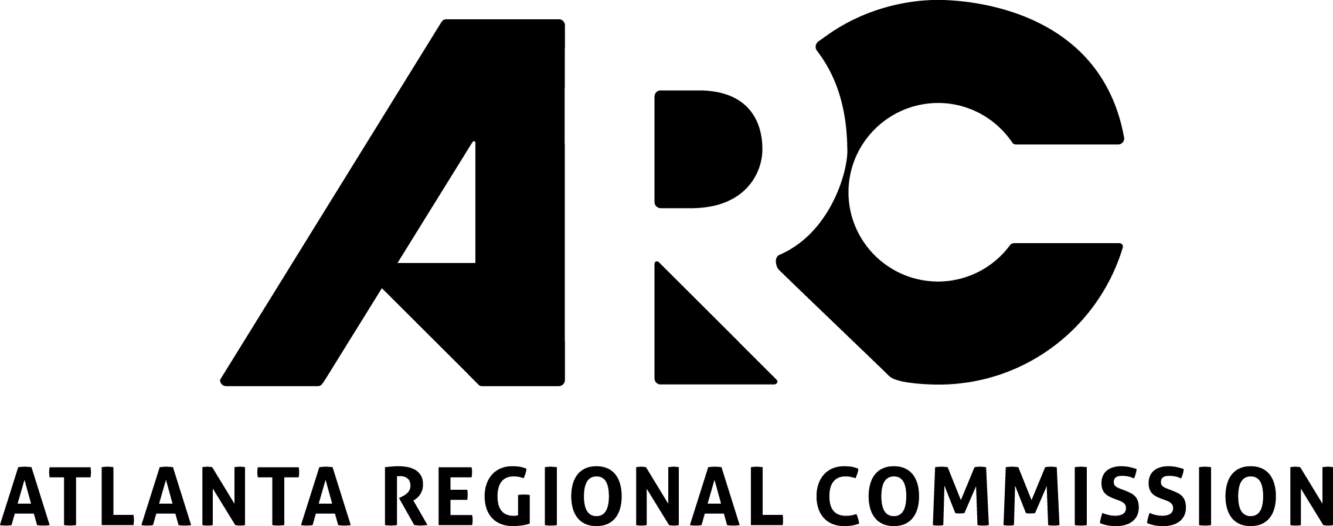
229 Peachtree St, Suite 100
Atlanta GA, 30303

2018 Livable Centers Initiative
Major Plan Update Application

This application is for existing LCI communities or sponsors who are seeking funding assistance to update their LCI plans.

Applicant Information:

Name of responsible organization: Click here to enter text.

(Eligible applicants include governmental entities, or Community Improvement Districts)

Name of contact person: Click here to enter text.

Title: Click here to enter text. Department: Click here to enter text.

Address/City/State/Zip: Click here to enter text.

Telephone: Click here to enter text. E-mail: Click here to enter text.

Plan Update Study Information and Justification:

Name of study, plan or work activity: Click here to enter text.

Location/jurisdiction(s) of study: Click here to enter text.

Name of existing LCI area(s): Click here to enter text.

Does this study area fall within an Equitable Target Area? See Equitable Target Area (ETA) Map
☐ Not within ETA
☐ Yes – Median range
☐ Yes – High range
☐ Yes – Very High range

Please provide a response to the following questions:

- Please provide a brief scope of work of the proposed study or activity. This can be in outline or bullet form listing specific study/consultant tasks with brief descriptions of each. If you have a more detailed Scope of Work or RFP available, feel free to include as an appendix. (max. 500 words):

Click here to enter text.

- Please describe how the conditions in the LCI study area has changed that update is needed in your community and what you hope it will achieve? Please be specific. (max. 250 words):

Click here to enter text.

- Please describe how this project/study supports regional goals established in The Atlanta Region’s Plan Policy Framework. (max. 250 words):

Click here to enter text.

- Please describe activities that your community (i.e. local government, CID, and/or community organizations) have undertaken which demonstrate its commitment and ability to implement the LCI plan and create positive changes at the community. You may attach an LCI Report of Accomplishments to the application, if available. (max. 350 words):

Click here to enter text.

- Please explain how your proposed study or activity will address one or more of the following LCI priorities or focus areas (250 words):
  - Mix of uses and a density of development that support walking, biking or transit
  - Mixed-income and workforce housing
  - Transit-oriented development or bicycle and pedestrian access to transit (including bus stops)
  - Redevelopment of underutilized infrastructure, brownfield, or grayfield sites
  - Jobs-housing balance and economic opportunity for all
  - Increased street connectivity, complete streets and Travel Demand Management
  - Creative placemaking strategies, creative public involvement and demonstration projects
  - Historic preservation and context-sensitive infill and development
  - Incorporation of Smart City transportation technology to improve mobility and congestion

Click here to enter text.

BUDGET:

Please list each task and the estimated total cost per task (i.e. not just the federal share). If you need more than six tasks, please attach a detailed budget.

Study/Project Tasks |  | Cost Estimate
Task 1: | Click here to enter text. | Click here to enter text.
Task 2: | Click here to enter text. | Click here to enter text.
Task 3: | Click here to enter text. | Click here to enter text.
Task 4: | Click here to enter text. | Click here to enter text.
Task 5: | Click here to enter text. | Click here to enter text.
Task 6: | Click here to enter text. | Click here to enter text.
TOTAL study/project budget |  | Click here to enter text.

Funds Requested (Max. 80% of Total Budget): Click here to enter text.

Sponsor Cash Match (Min. 20% of Total Budget): Click here to enter text.

Please note: All LCI studies must include at least 20% cash match of the total study budget. The maximum funding request is $200,000 (i.e. $250,000 total, $200,000 fed/$50,000 local).

SUBMITTAL PACKAGE CHECKLIST:

Your completed LCI Major Plan Update Application should include the following:

☐ Completed 2018 LCI Plan Update Application (i.e. this form!)

☐ A clear map of the proposed study/project area. Include jurisdiction boundaries, major street names, a scale, legend, north arrow, the existing LCI area, and any adjacent LCI boundaries on the map.

☐ Resolutions or Letters of Commitment:
☐ Include a letter of commitment from the Mayor or City/County Manager, or a Council Resolution, indicating commitment to the implementation of the project and providing matching funds.

☐ Non-governmental organizations applying for funds shall include a letter of commitment to the implementation of the project and providing the matching funds, from its Executive Director or Board Chairperson, as well as a letter of support from the underlying jurisdiction.

☐ If entities other than the applicant are providing matching funds, please include letters of commitment for the matching funds from those entities.

☐ Copy of the Council/Commission resolution adopting the original LCI Study or most recent LCI Plan Update (if applicable).

☐ Optional: Supporting documentation such as support letters from stakeholders and community, LCI Report of Accomplishments, detailed scopes of work, photos, etc. Please limit to 15 pages.

How to Submit Application:

Combine all documents from the Submittal Package Checklist into a single PDF with the name of your study area in the file name and submit by November 17, 2017 via email, FTP or USB drive to:

Jared Lombard, Community Development Group,
Atlanta Regional Commission
229 Peachtree Street, Suite 100, Atlanta, GA 30303
jlombard@atlantaregional.org
470-378-1589

For information and questions: See the application website https://atlantaregional.org/community-development/comprehensive-planning/livable-centers-initiative/ or contact ARC’s Community Development Group: Jared Lombard jlombard@atlantaregional.org

Submittal Deadline:
November 17, 2017 by 5pm

